# Subsetting Rows - Family Members Less Than 1,000 and Region is Pacific

This document includes the question, the solution, and a breakdown of the code provided in the screenshot.

## Uploaded Screenshot

Below is the screenshot of the task:

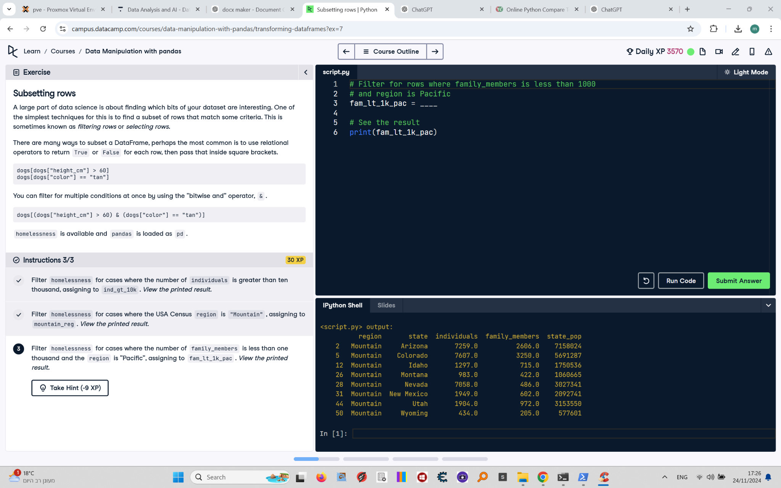

## Question

Filter `homelessness` for cases where the number of `family_members` is less than one thousand and the region is "Pacific", assigning the result to `fam_lt_1k_pac`. View the printed result.

## Answer

# Filter for rows where family_members is less than 1000 and region is Pacific  
fam_lt_1k_pac = homelessness[(homelessness["family_members"] < 1000) & (homelessness["region"] == "Pacific")]  
  
# See the result  
print(fam_lt_1k_pac)

## Code Explanation

# Explanation of the code:

1. `(homelessness["family_members"] < 1000)`: Creates a boolean mask for rows where the `family_members` column has values less than 1,000.

2. `(homelessness["region"] == "Pacific")`: Creates a boolean mask for rows where the `region` column has values equal to "Pacific".

3. `&`: Combines the two masks using the bitwise AND operator, ensuring both conditions are met.

4. `homelessness[...]`: Filters the `homelessness` DataFrame to include only rows where the combined mask evaluates to `True`.

5. `fam_lt_1k_pac`: Stores the filtered DataFrame for further use.

6. `print(fam_lt_1k_pac)`: Prints the resulting DataFrame to verify the filter.